Educational Psychology Review (2024) 36:8 https://doi.org/10.1007/s10648-023-09842-1 ESSAY The Past, Present, and Future of the Cognitive Theory of Multimedia Learning Richard E. Mayer1 Accepted: 25 December 2023 / Published online: 17 January 2024 © The Author(s) 2024 Abstract The cognitive theory of multimedia learning (Mayer, 2021, 2022), which seeks to explain how people learn academic material from words and graphics, has devel oped over the past four decades. Although the name and graphical representation of the theory have evolved over the years, the core ideas have been constant—dual channels (i.e., humans have separate information processing channels for verbal and visual information), limited capacity (i.e., processing capacity is severely limited), and active processing (i.e., meaningful learning involves selecting relevant material to be processed in working memory, mentally organizing the material into coher ent verbal and visual structures, and integrating them with each other and with rel evant knowledge activated from long-term memory). This review describes how the theory has developed (i.e., the past), the current state of the theory (i.e., the present), and new directions for future development (i.e., the future). In addition, the review includes examples of the events and findings that led to changes in the theory. Impli cations for educational psychology are discussed, including 15 evidence-based prin ciples of multimedia design. Keywords Multimedia learning · Theory development · Learning theory · Instructional design · Meaningful learning Introduction to the Cognitive Theory of Multimedia Learning The cognitive theory of multimedia learning (CTML) represents my continuing and evolving attempt to understand how meaningful learning works. Meaningful learn ing occurs when the learner engages in appropriate cognitive processing during learning, including attending to the relevant information in a lesson (i.e., selecting), This article is part of the Topical Collection on Theory Development in Educational Psychology. * Richard E. Mayer mayer@psych.ucsb.edu 1 University of California, Santa Barbara, CA, USA Vol.:(0123456789) 1 3 Content courtesy of Springer Nature, terms of use apply. Rights reserved.

8 Page 2 of 25 Educational Psychology Review (2024) 36:8 mentally organizing the incoming information into a coherent cognitive structure (i.e., organizing), and connecting it with relevant knowledge activated from long term memory (i.e., integrating; Mayer, 2021, 2022). Meaningful learning is indi cated by performance on transfer tests, which involves being able to use the learned material in new situations. CTML focuses on how people learn meaningfully from academic material containing words and graphics. It focuses on techniques that prime appropriate cognitive processing during learning. The development of new theories such as CTML is shaped by existing theories. For example, Camp et al. (2022) point out that CTML builds on classic conceptual frameworks from cognitive psychology, including dual-coding theory (Paivio, 1986), multi-stage model of memory (Baddeley, 1986), and cognitive load theory (Sweller, 1999, in press; Sweller et al., 2011). In particular, Camp et al., (2022, p. 17) note: The power of theories is that they have the potential to remain valid and rel evant through generations, while the power of new theories is that they build upon and expand those old theories. You might say that the old theories are the giants upon whose shoulders new theories, and thus new giants, stand. The cognitive theory of multimedia learning (CTML) ...can be regarded as one such new giant. The creation of CTML is clearly a team effort within the field of educational psy chology. My modest goal in this essay is to share some introductory insights gleaned from my efforts at theory-building over the past decades, describe the evolution of CTML, summarize the current state of CTML, and speculate on possible future directions for CTML. First, in line with Greene’s (2022) call to carefully examine the process of theory development in educational psychology, I share seven insights about theory building that are exemplified in my decades-long attempts to explain how people learn from multimedia lessons. Insight 1: Theory Building Depends on Intellectual Curiosity CTML is a manifestation of my lifelong quest to understand how meaningful learning works. I began my journey on one of those amazing, crisp autumn days in Ann Arbor in 1969, as I started my graduate career in psychology at the University of Michi gan. Soon within my first year in graduate school, under the mentorship of James Greeno, I developed a deep curiosity about how meaningful learning works. How can we teach so people can take what they have learned and use it productively in new situations? This seemingly simple question about teaching for transfer has been a driving force in my lab across more than four decades. Specifically, CTML focuses on some fundamental questions about learning and instruction with multimedia mate rials: How do people learn academic material consisting of words and graphics (i.e., multimedia learning)? How can we help people learn academic material consisting of words and graphics (i.e., design of multimedia instruction)? My curiosity about these kinds of questions is the engine that drives the development of CTML. How did I get started on this theory-developing journey? During my first year of graduate school, while I was struggling to build my identity as a research

Educational Psychology Review (2024) 36:8 Page 3 of 25 8 psychologist, I had the good fortune to take a course entitled, Models of Thinking, taught by my advisor, Jim Greeno. That course got me thinking about how people are able to come up with creative solutions to problems, which lead me to a basic question: “How can we help people learn in ways so that they can take what they have learned and apply it to new situations?” This question about teaching for trans fer, which formed in my mind during that course, has stuck with me all these years and has driven my research. I soon discovered that this is a classic, albeit elusive, issue both in psychology and in education that dates back to early days of research in learning and instruction. Insight 2: Theory Building Is Grounded in Old Ideas The search for theories of meaningful learning has a long history, including the insightful work of the Gestalt psychologists such as Wertheimer (1959) and Katona (1940); the groundbreaking work of developmentalists such as Piaget (1926) and Vygotsky (1978); and the creative work of memory researchers such as Bartlett (1932). In the field of educational psychology, a focus on instruction for meaningful learning has its roots in generative theories of learning by pioneers such as Wittrock (1974, 1989) and Ausubel (1968). Some key ideas rising from this work are mean ingful learning as assimilation to schema (i.e., connecting incoming information with existing knowledge), meaningful learning as a generative activity (i.e., actively attending to relevant material, organizing it into a coherent structure, and relating it to relevant prior knowledge), and meaningful learning as knowledge construc tion (i.e., building mental representations in working memory). The development of CTML represents my attempts to understand and clarify these intriguing ideas based on empirical testing. How did I get this insight? As an undergraduate, my goal was to read every clas sic psychology book, but in graduate school, my goal became more focused on read ing every classic book related to how learning works and, particularly, books that could help me better understand my driving question of how to teach for transfer. I found amazing used bookstores in Ann Arbor, where I spent a lot of my spare time on a treasure hunt for books by the likes of Piaget (1926), Bartlett (1932), Wertheimer (1959), Katona (1940), Ebbinghaus (1913), Ausubel (1968), and many others. I was moved by the introductory quotation I found on the cover page to Ebb inghaus’ nineteenth century book, Memory: “From the oldest subject we will build the newest science.” Even as a beginning graduate student, I felt privileged to con tribute in even a small way to this newest science of how the human mind works, which in my case turned out to the science of learning and instruction. Insight 3: Theory Building Is Not a Straight, Planned-Out Path My search for a theory of meaningful learning has not taken a straight, planned-out path, but rather has progressed in an irregular pattern of small steps based on for tuitous findings over decades, with invaluable contributions from a long list of col laborators and colleagues. CTML was not based on a systematic step-by-step career

plan, and it certainly did not pop out of my head one day all in one nice polished package. It came out in fits and starts, with a long series of revisions, refinements, clarifications, deletions, and additions. Where does this idea come from? I never set out to have a long-term career plan of systematic research on multimedia learning, but rather I have much shorter 2- or 3-year plans targeted on specific research questions. For example, back in the 1980s, after reading all of David Ausubel’s (e.g., Ausubel, 1968) writings, I became obsessed with advance organizers—material that is presented before a lesson that is intended to improve learning through activating relevant prior knowledge. That line of research led me to the unexpected conclusion that visual advance organiz ers could be effective in helping learners relate a new concept with familiar prior knowledge, which got me thinking about the power of connecting visual and verbal representations as a route to meaningful learning. As that idea incubated in my mind throughout the late 1980s and 1990s, I became interested in how to incorporate illustrations in text. That fateful exploration brought me to the formulation of what was to become the multimedia principle—people learn better from words and pic tures than from words alone. In short, I often do not know where my theory-building is going but I simply follow the fruitful paths that my current research takes me. Insight 4: Theory Building Is an Engineering Problem Based on this journey, I have come to realize that theory building in educational psychology is much like solving a practical engineering problem. However, instead of building an increasingly better device to carry out some function, our theory building task is to build a progressively better explanation of some educationally rel evant phenomenon (such as how students develop meaningful learning that transfers to new situations). I just keep tinkering with the theory trying to make it work better based on new research evidence and logical reasoning. One indication of working better is the rate at which the work is cited by others and incorporated into their frameworks, as documented by Camp et al. (2022). Where does this insight come from? When I look at the evolution of CTML, par ticularly through the ways I represented it visually, I see that I started with a core idea—there are several cognitive conditions for meaningful learning—and then con tinually tweaked the idea based on the research evidence that it generated and the new ideas I came across. When I read Paivio’s (1986) work on dual-coding, I real ized its relevance and tried to incorporate that idea. When I read Miller’s (1956) and Baddeley’s (1986) and Sweller’s (1999) work on limited working memory capac ity, I realized that fundamental idea had to be part of my theorizing. When I read Wittrock’s work on generative learning, it validated my thinking that appropriate cognitive processing during learning was a key to meaningful learning and led to my incorporating the SOI model (based on selecting, organizing, and integrating). As in engineering, my approach has been to keep redesigning what I have to make it bet ter—which in my case means making it better able to explain a wider set of findings. In this way, my work began with what Kuhn (1962) would call a paradigm shift—a

shift from behaviorist to cognitive views of how learning works—but then for all these ensuing years has involved continually improving on my original idea. Insight 5: Theory Building Is an Iterative Process Involving the Persistent Interplay Between Research and Theory As shown in Fig. 1, consistent with Greene (2022), I start with the kernel of a theo retical idea (i.e., theory), which leads me to a testable question (i.e., research ques tion) that I examine in series of experiments (research design), which generates a pattern of findings (research evidence) that helps me improve my theoretical account (theory). The development of CTML represents many turns around the circle pre sented in the figure (both clockwise and counterclockwise). These turns depend on valuable discussions with colleagues concerning how to frame the next version of the theory, how to generate useful research questions (and know when to give up on unfruitful ones), how to design impactful studies, and how to interpret the results. The result is a series of iterations of a theory of how meaningful learning works, as described in the following sections. Where did I get this insight? Let me give an example. Most of the early work by my collaborators and me on instructional design principles for multimedia learn ing focused on the instructional goal of reducing extraneous processing—that is, reducing the learner’s cognitive processing that is not directed towards learning the content so that the learner can use cognitive resources to make sense of the mate rial. This led, for example, to the coherence principle in which people learn better when we remove unneeded visual and verbal material from a lesson. However, for some lessons, even when we eliminated unneeded material, students still had trouble learning it, perhaps because they just did not want to put out effort to make sense of
Fig. 1 The theory-research cycle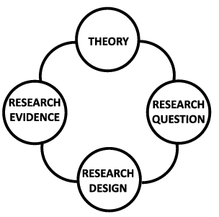

the material. This led us to develop a new kind of instructional design goal, which I called fostering generative processing—motivating the learner to actively engage with the material. This goal suggested a whole new set of multimedia learning tech niques based on prompts to engage in generative learning activities during learning, such as writing a summary, drawing an illustration, creating a graphic organizer, and explaining to others. In this way, the research evidence (i.e., not being able to improve learning through reducing extraneous material), led to a new theoretical idea (i.e., fostering generative processing) which led to new research avenues (i.e., incorporating generative learning activities). Insight 6: Theory Building Depends on Persistence in Collecting New Research Evidence Also in line with Fig. 1, building the cognitive theory of multimedia learning depends on a persistent commitment to experimental comparisons using a value added design. In value-added experiments, we compare the learning outcomes (and, when possible, learning processes) of people who learn from a base version of a multimedia lesson with those of people who learn from the lesson with one feature added. For example, we can compare learning from a narrated animation on light ning formation versus learning from the same lesson with the words presented as printed captions at the bottom of the screen. Theory development depends on a strong foundation of research evidence, which flows from a willingness to replicate effects detected in value-added studies. Where did this insight come from? Let me give you an example. When Roxana Moreno was a graduate student in my lab, she came to my office with the preposter ous (to my way of thinking) idea that using conversational language in an online sci ence lesson would improve learning outcomes over our existing lessons using tradi tional, formal language. In spite of my skepticism, we worked out plans for a series of rigorous experiments, each one of which came back with strong positive results. After replicating the effect multiple times with multiple content topics, I finally allowed myself to share the personalization principle with the larger research com munity, that is, the idea that people learn better when instructors use conversational wording rather than formal wording. This opened my eyes to the idea that online multimedia learning depended not only on cognitive processing, but also social and affective processing, which has led to several ongoing new directions for our research (Horovitz & Mayer, 2021; Lawson & Mayer, 2022; Lawson et al., 2021). Insight 7: Theory Building Is a Team Activity CTML would not have happened if I was tasked with working alone. I have had the pleasure of working with dozens of collaborators over the years who have helped build CTML. The theory benefits from collaborations with students, campus col leagues, and fellow educational psychologists from near and far, including visitors from around the world who have contributed to our lab over the years. The theory has been shaped by advances and feedback from the larger community of scholars,

many of whom are represented in the various editions of The Cambridge Handbook of Multimedia Learning (Mayer, 2005, 2014; Mayer & Fiorella, 2022). CTML also has benefitted from ideas from competing theories such as cognitive load theory (Paas & Sweller, 2022; Sweller, 1999, in press; Sweller et al., 2011) or the inte grated model of text and picture comprehension (Schnotz, 2022, 2023). Part of the ory building is being able to convince your peers and to be convinced by them. Where did this insight come from? As I look over the hundreds of research papers on multimedia media that have my name on them, I see that the vast majority were co authored with graduate students or visitors to my lab. I seek to meet on a weekly basis with our lab research team—graduate students, postdocs, and visitors. I also meet regu larly with students, visitors, colleagues, and anyone else I can find who is interested in talking about improving multimedia instruction. I cherish these meetings because they are essential in giving me a chance to work out new ideas about multimedia learning. The Past of the Cognitive Theory of Multimedia Learning I did not plan to spend a substantial portion of my academic career on developing the cognitive theory of multimedia learning. In this section, I briefly describe how it happened, including how I stumbled upon an appropriate name and a concise vis ual representation, how I searched for a conceptual framework, and how CTML has grown in terms of research base and design principles. Stumbling Upon a Name for the Theory An important challenge in theory development is to find a name that highlights the key concepts in the theory. Table 1 summarizes the names leading up to the cog nitive theory of multimedia learning, which highlighted an evolving collection of inter-related concepts. I began with “model of meaningful learning” (Mayer, 1989), which focused on the external conditions for instruction for meaningful learning— namely, having potentially meaningful material, having learners who need help, having illustrations that provide help, and having a test that can detect meaningful learning outcomes. I changed the name to “model of conditions for effective illustra tions” in Mayer & Gallini (1990) but retained the same set of conditions albeit in a different order. How did I progress to the next levels? In continually discussing our theoretical account with students and colleagues, it became clear that this initial model cap tured the external factors involved in meaningful learning but did not adequately address the internal cognitive processes involved. If I wanted to know how meaning ful learning works, I would have to consider the cognitive processes during learning. I was heavily influenced by three threads of scholarship I had been reading about— dual-coding such as articulated by Paivio (1986), limited working memory capacity such as articulated by Miller (1956) and Baddeley (1986) and Sweller (1999), and active cognitive processing during learning such as articulated by Wittrock (1974, 1989). First, I focused on dual-coding

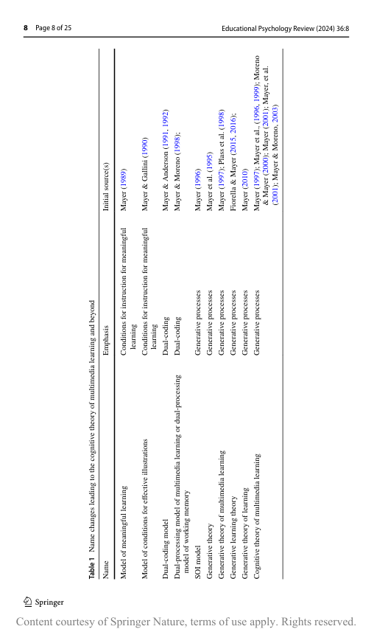

As a result of my dissatisfaction with a focus solely on external conditions of meaningful learning, the names shifted to focus on the internal conditions for mean ingful learning by considering cognitive processing in the learner’s information pro cessing system. Different names emphasized different aspects of cognitive processing such as having dual-channels for verbal and visual material, having limited capac ity for cognitive processing, and engaging in generative processing during learning. First, I emphasized the concept of dual-coding (i.e., separate information process ing channels for auditory and visual material) with names like “dual-coding model” (Mayer & Anderson, 1991, 1992) and “dual-processing model of multimedia learn ing” or “dual-processing theory of working memory” (Mayer & Moreno, 1998). The idea of separate channels for processing visual and verbal material was to become a central feature of CTML, as represented by the two rows in the current model. Then, the name was broadened to differentiate among three cognitive processes during learning—selecting relevant material for further processing, organizing it into a coherent cognitive representation, and integrating it with relevant prior knowledge. Mayer (1996) referred to this idea as the “SOI model,” and other papers used the term “generative theory” (Mayer, 1997; Mayer et al., 1995) or “generative theory of mul timedia learning” (Mayer, 1997; Plass et al., 1998) or “generative learning theory” (Fiorella & Mayer, 2015, 2016) or “generative theory of learning” (Mayer, 2010). The SOI model was a major conceptual breakthrough for me, and has remained at the core of CTML ever since, as represented by the arrows in the current model. In short, the SOI model represents the core cognitive processes that drive CTML. Finally, we began using the name, “cognitive theory of multimedia learning” in Mayer et al., (1996, 1999), Mayer (1997), and Moreno & Mayer (2000). We also elaborated on the underlying ideas of the cognitive theory of multimedia learning in Mayer & Moreno (2003) and all editions of Multimedia Learning (Mayer, 2001, 2009, 2021) and all editions of The Cambridge Handbook of Multimedia Learning (Mayer, 2005, 2014; Mayer & Fiorella, 2022). This approach included the idea of limited capacity and the distinction among extraneous, essential, and generative pro cessing in which cognitive capacity directed at extraneous processing reduced the capacity available for essential and generative processing. How am I progressing beyond the current model of CTML? Research evidence came pouring in that alerted me to the idea that there may be more to multimedia learning than cognitive processing. We began to find evidence for the role of social process (e.g., how using conversational language can build social rapport) and affec tive processing (e.g., how the instructor’s gestures and tone of voice can affect learn ing), and evidence for the role of motivational factors (e.g., benefits of training for self-efficacy in multimedia lessons) and metacognitive factors (e.g., role individual differences in executive function in learning from distracting lessons). We are now grappling with how to represent these additions to CTML. As we move to expand CTML, as summarized in Table 2, we supplemented CTML with “social agency theory” (Atkinson et al., 2005; Mayer et al., 2003), which incorporates social processes during learning, and with the “cognitive-affec tive theory of learning with media” (Moreno & Mayer, 2007) and the “cognitive affective model of e-learning” (Lawson & Mayer, 2022; Lawson et al., 2021), which incorporates affective processes during learning.

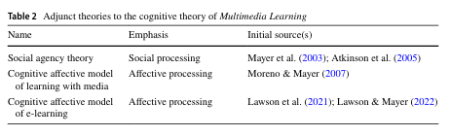

The name changes reflect a shift from a focus on external conditions to inter
nal processes ranging from dual-coding processing to generative processing to
social and affective processing. Although it took us more than a decade to get there,
throughout the twenty-first century, we have landed on the “cognitive theory of mul
timedia learning” as the name of our theory.
Inching Towards a Visual Representation of the Theory
Although it took many iterations to find a suitable name, we also struggled with
finding an appropriate visual representation of the theory. I have found that visual
representations help me better understand and improve on the theory, so I generally
start with a visual representation and then express my ideas in words. In the case
of CTML, it took many tries at building a flowchart that could represent the theory
concisely and accurately. Our earliest attempts are shown in Figs. 2 and 3, which
depict the external conditions for effective multimedia instruction—having mean
ingful text, having complimentary illustrations, having learners who need help, and
having a test that taps meaningful learning (Mayer, 1989; Mayer & Gallini, 1990).
Next, we shifted from a vertical flowchart depicting external conditions of mean
ingful learning to a vertical flowchart depicting steps in a dual-coding model (in
Fig. 4; Mayer & Anderson, 1992). In a further refinement of the dual-coding model,
we flipped to a horizontal flowchart involving a visual channel and an acoustic chan
nel (in Fig. 5; Mayer & Moreno, 1998). Around the same time, we developed a more
inclusive flowchart based on a generative theory that broadened the cognitive pro
cesses to include selecting, organizing, and integrating, but without the dual chan
nels (in Fig. 6; Mayer, 1996). Figure 7 shows a flowchart version of generative the
ory (with selecting, organizing, and integrating) that also begins to incorporate dual
channels involving text and illustrations (Mayer, 1997; Mayer et al., 1995).
Finally, in Fig. 8 (Mayer, 2001; Mayer et al., 2001), we refined those previ
ous flowcharts to include all three features of the theory: dual-channels as rep
resented by an auditory row across the top and a visual row across the bottom;
limited capacity as represented by boxes for sensory memory, working memory,
and long-term memory; and generative processing as indicated by arrows for
selecting, organizing, and integrating. This has become the stable flowchart rep
resentation we have used to depict the cognitive theory of multimedia learning
throughout the twenty-first century. It is the single most important representa
tion of CTML, and it continually helps me think about how multimedia learning

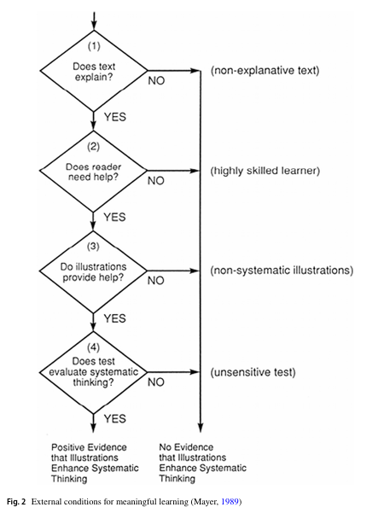

works and the implications for instructional design. On reflection, it seems fitting that the most important statement of CTLM is itself a multimedia representation consisting of words and graphics. Going beyond the standard flowchart for CTML in Fig. 8, we also have added some complementary flowcharts for social agency theory (Mayer, 2009), which adds social processing, and for the cognitive-affective model (Lawson & Mayer, 2022; Moreno & Mayer, 2007), which adds affective processing. The changes in our

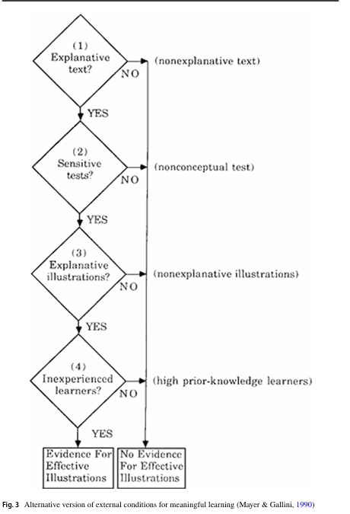

flowchart reflect refinements and additions in the theory, as we grappled with how to integrate an inter-related set of concepts about dual channels, limited capacity, and active processing

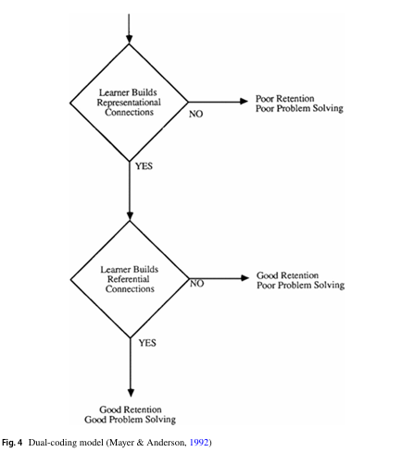

Adding to the Research Base Across four decades, the research base for the cognitive theory of multimedia learn ing has grown substantially, which enabled further theory development. Table 3 shows the number of experimental tests conducted by my colleagues and me as well as the number of multimedia design principles we have proposed based on those studies across the three editions of Multimedia Learning (Mayer, 2001, 2009, 2021). Starting with our first multimedia learning studies in 1989, we have been able to generate 15 evidence-based principles based on more than 200 experiments con ducted by my colleagues and me. Table 4 lists the principles that were included in each of the three editions of Mul timedia Learning. As can be seen, we began mainly with principles aimed at mini mizing extraneous processing—cognitive processing that does not support the instruc tional goal—such as eliminating unneeded material (i.e., coherence principle). Then,

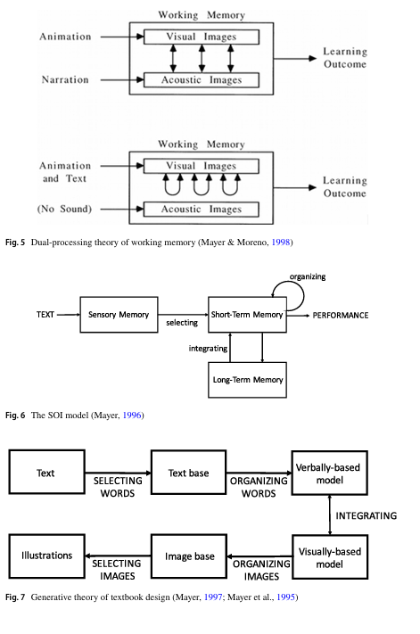

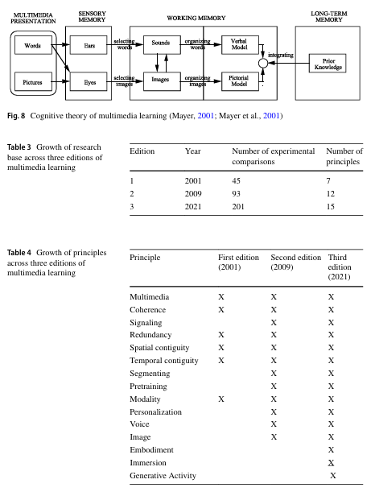

we added principles aimed at managing essential processing—cognitive processing aimed at representing the material in working memory—such as pausing a continuous video to create self-paced segments (i.e., segmenting principle). Lastly, we added prin ciples aimed at fostering generative processing—cognitive processing aimed at mak ing sense of the material—mainly with new technologies such as asking learners to summarize or explain what they are learning (i.e., generative activity principle).

Of course, the growth of the research base supporting CTML goes far beyond what our lab produces and includes an ever expanding network of researchers around the world. As summarized in Table 5, some of this work is described in the three editions of The Cambridge Handbook of Multimedia Learning (Mayer, 2005, 2014; Mayer & Fiorella, 2022). This growth in the research base is supported by improvements in assessment of learning outcomes—especially the development of appropriate transfer tests. I am a strong proponent of replication and for searching for boundary conditions under which the various design principles apply. Overall, theory development depends on a storehouse of research evidence generated by labs around the world. The Present State of the Cognitive Theory of Multimedia Learning The cognitive theory of multimedia learning is an evidence-based description of how people learn from multimedia instructional messages. A multimedia instruc tional message is instructional material consisting of words (e.g., printed text or spo ken text) and graphics (e.g., illustrations, photos, animation, video, or immersive virtual reality) intended to foster new knowledge or skills in a learner. A multime dia instructional message can be presented in print (e.g., as a book), on a computer screen (e.g., as an instructional video or narrated animation or a simulation game), or in virtual reality via a head-mounted display (e.g., as an interactive simulation). The theory yields implications for the design of effective multimedia instructional messages, which are rendered as design principles. Some of the advances in CTML have been fostered by advances in educational technology including instructional video, animation technology, technologies for creating onscreen agents, immersive virtual reality, and educational games, but it was not my intention to study educational technology per se. In fact, the theory began by studying learning from printed text and illustrations rendered on paper, and my focus has always been on how to design effective instruction involving words and graphics. In short, my focus is on how to help people learn academic content rather than on the capabilities of the latest educational technologies. In this section, I summarize the current state of the cognitive theory of multime dia learning including the guiding assumptions, the memory stores, the cognitive processes, the demands on cognitive capacity, and three instructional goals. I also summarize 15 evidence-based multimedia instructional design principles based on CTML. More detailed descriptions are available in Mayer (2021, 2022)

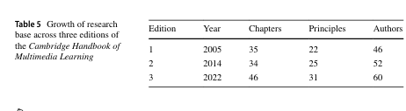

The cognitive theory of multimedia learning is represented in Fig. 8. A multime dia instructional message enters the learner’s cognitive system through their eyes and ears. Printed words and graphics are held briefly in visual sensory memory, and spoken words are held briefly in auditory sensory memory. As these images fade, the learner can pay attention to some of the material, which is transferred to work ing memory for further processing. In working memory, the learner can organize the pictorial material into a pictorial model and the verbal material into a verbal model and integrate corresponding pictorial and verbal representations with each other and with relevant knowledge from long-term memory. The outcome is meaningful knowledge that is stored in long-term memory and can be applied to new situations. Guiding Assumptions of the Cognitive Theory of Multimedia Learning The cognitive theory of multimedia learned as represented in Fig. 8 is based on three guiding assumptions derived from cognitive science: dual channels, limited capacity, and active processing. The dual-channels assumption is that humans have separate but interacting channels for processing auditory/verbal information and pictorial/visual information (such as narration and animation, respectively). The limited-capacity assumption is that humans can process only a few pieces of infor mation in each channel at one time. The active-processing assumption is that mean ingful learning occurs when the learner engages in appropriate cognitive process ing during learning, including selecting relevant material to attend to in a lesson, mentally organizing the incoming material into a coherent representation in working memory, and mentally connecting it with corresponding representations and with relevant prior knowledge activated from long-term memory. Three Memory Stores in the Cognitive Theory of Multimedia Learning CTML has three memory stores, which are represented as boxes in Fig. 8 sensory memory, working memory, and long-term memory. Sensory memory holds com plete visual images (in visual sensory memory) that enter through the eyes and com plete auditory images (in auditory sensory memory) that enter through the ears, but the images fade rapidly within a fraction of a second. Working memory holds picto rial/visual and auditory/verbal pieces of information that the learner has attended to before they decay from sensory memory. This information can be re-arranged, but only a few pieces of information can be processed in each channel at any one time. Long-term memory is the learner’s permanent storehouse of knowledge, parts of which can be activated and brought into working memory during learning. Five Cognitive Processes in the Cognitive Theory of Multimedia Learning CTML has five cognitive processes, which are represented as arrows in Fig. 8: selecting words, selecting images, organizing words, organizing images, and

integrating. Selecting words refers to attending to relevant parts of the printed text, and selecting images refers to attending to relevant parts of the presented graph ics. Organizing words refers to arranging the relevant words in to a verbal model in working memory, and organizing images refers to arranging the relevant parts of the graphics into a pictorial model in working memory. Integrating refers to making connections between corresponding verbal and pictorial representations in working memory as well as relevant knowledge from long-term memory. Meaningful learn ing depends on the learner engaging in appropriate cognitive processing involving selecting, organizing, and integrating. Instructional design is intended to guide these processes. Three Demands on Cognitive Capacity A central tenet of the cognitive theory of multimedia learning is that working memory capacity is limited, but there are three demands on that limited cognitive capacity during learning: extraneous processing, essential processing, and genera tive processing. Extraneous processing is cognitive processing that does not support the instructional goal; the amount of extraneous processing depends on the degree of poor instructional design, such as presenting extraneous verbal or pictorial infor mation in a lesson. Essential processing is cognitive processing to mentally repre sent the presented material in working memory; the amount of essential processing depends on the inherent complexity of the material for the learner, such as present ing many inter-related concepts in a fast-paced lesson. Generative processing is cog nitive processing aimed at making sense of the incoming information; the amount of generative processing depends on the learner’s level of motivation to exert effort to understand the lesson. The three kinds of processing each require some of the learn er’s limited cognitive capacity, so capacity that is used for extraneous processing takes away from capacity that could be used for essential and generative processing, and cognitive capacity that is used for essential processing takes away capacity that could be used for generative processing. Three Instructional Goals The three demands on cognitive capacity give rise to three instructional goals: mini mize extraneous processing, manage essential processing, and foster generative pro cessing. Consider a situation in which a poorly designed lesson causes the learner to allocate almost all of their cognitive capacity to extraneous processing, so they do not have adequate remaining cognitive capacity to engage in needed essential and generative processing. In this case, an important instructional goal is to mini mize extraneous processing. This can be accomplished, for example, by eliminating unneeded words and graphical elements from a lesson. Consider another situation in which extraneous processing has been reduced, but the lesson is so complex that the amount of needed essential processing exceeds the learner’s cognitive capacity. In this case, an important instructional goal is to

manage essential processing. This can be accomplished, for example, by breaking a continuous lesson into manageable chunks that can be paced by the learner. Finally, let us assume that we have minimized extraneous processing and man aged essential processing, so cognitive capacity is available for generative process ing, but the learner is not motivated to exert effort to understand the material. In this case, an important instructional goal is to foster generative processing. This can be accomplished, for example, by prompting the learner to engage in a generative learning activity such as writing a summary or self-testing during pauses a lesson. Fifteen Multimedia Instructional Design Principles Table 6 summarizes 15 principles supported by research by my colleagues and me over the years. The first set of five principles addresses the instructional goal of reducing extraneous processing; the second set of four principles addresses the instructional goal of managing essential processing; and the third set of six princi ples addresses the instructional goal of fostering generative. Each principle is sub ject to boundary conditions including for whom the principle applies, for which kind of lesson the principle applies, and under what circumstances the principle applies. These are described in more detail in Multimedia Learning (Mayer, 2021). Many more principles are described in the wider literature, such as in The Cambridge Handbook of Multimedia Learning (Mayer & Fiorella, 2022). The Future of the Cognitive Theory of Multimedia Learning Even when a theory reaches a somewhat stable state, such as the cognitive theory of multimedia learning, there is still room for further theory development. Today’s version of CTML focuses mainly on cognitive processing during learning—such as selecting, organizing, and integration—as the core mechanism along with assump tions about the architecture of the human information processing system, limited capacity of working memory and dual channels for visual and verbal processing. In this section, I explore future directions for CTML involving the integration of new learning components that go beyond these basic cognitive processes, such as social processes, affective processes, motivational processes, and metacognitive pro cesses. In the future, I also expect an increase in the research base, an increase in the number of evidence-based design principles, and a clearer specification of boundary conditions for design principles. Integrating New Components into the Cognitive Theory of Multimedia Learning Progress is being made in integrating understudied components into the cognitive theory of multimedia learning, including social, affective, motivational, and meta cognitive processes. Concerning social processes, initial progress is reflected in the incorporation of social agency theory (Atkinson et al., 2005; Mayer et al., 2003), which posits that learners try harder to understand a lesson when they feel that the

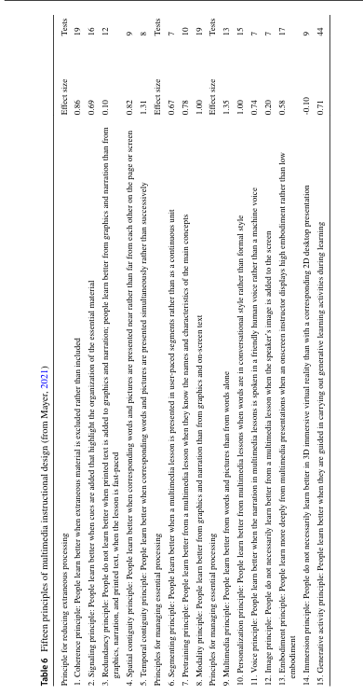

instructor is working with them. Concerning affective processes, initial progress is reflected in the incorporation of the cognitive-affective model of learning with media (Moreno & Mayer, 2007) and the cognitive-affective model of e-learning (Lawson et al., 2021; Lawson & Mayer, 2022), which posit that learners try harder to understand a lesson when they experience positive emotion while learning. Con cerning motivational processes, initial progress is reflected in research showing students learn better from a statistics lesson when they are given prompts intended to boost their self-efficacy and decrease anxiety during learning (Huang & Mayer, 2019; Huang et al., 2020). Concerning metacognitive processes, initial progress is reflected in research assessing learners’ judgements of understanding during pauses in a multimedia science lesson (Pilegard & Mayer, 2015a, 2015b). Overall, more work is needed to incorporate new components into the cognitive theory of multimedia learning, especially given ongoing advances in theories of self-regulated learning and motivation. For example, Kuhlmann et al. (2023) have shown how the SOI processes in CTML can be expanded through a motivational theory perspective. Clearly, self-regulation plays an important role in understanding how students learn from multimedia materials and in understanding how to design multimedia instructional materials for students with different kinds of self-regula tion skills. Expanding Research Methodologies to Monitor Learning Processes In order to incorporate new components into the CTML, we need to expand the research methodologies used to monitor learning processes, including the use of eye-tracking, biometric, brain monitoring, and survey techniques. Concerning eye tracking techniques, progress is being in determining how learners allocate their attention in viewing a multimedia lesson, such as how many times their eyes move between corresponding printed words and graphical elements (Johnson & Mayer, 2012; Ponce et al., 2018) or where students look when viewing a video lecture consisting of an instructor standing next to projected slides (Stull & Mayer, 2021; Stull, et al., 2018). Concerning biometric techniques, initial progress is reflected in studies examining students’ emotional arousal as measured by heart rate variability and electro-dermal activity when learning in immersive virtual reality versus with conventional media (Parong & Mayer, 2021a, 2021b). Concerning brain monitoring techniques, initial progress is reflected in studies examining students’ level of dis traction as measured by a portable electroencephalogram (EEG) system when learn ing in immersive virtual reality versus with conventional media (Parong & Mayer, 2021a, 2021b). Similarly, functional near-infrared spectroscopy (fNIRS) technology offers a potential avenue for detecting the intensity of activity in brain areas related to cognitive, social, and affective processing (Li et al., 2022). The traditional way to measure learning activities is through self-report surveys administered after learn ing, but initial progress is being made in injecting brief survey items at pauses within an ongoing lesson (Pilegard & Mayer, 2015a, 2015b). Overall, I expect advances in methodologies aimed at detecting learning processes during an instructional epi sode, which will complement existing techniques to measure learning outcomes.

Expanding the Knowledge Base Finally, I expect the cognitive theory of multimedia learning to be fortified with an increase in the research base, which will enable an increase and refinement in design principles and a clearer specification of boundary conditions for when a principle is most likely to apply. As the research base grows, I expect to see more meta-analyses that pinpoint the strength of key multimedia design principles as well as their mod erating factors. An important direction for future research is to conduct studies in more natural learning environments such as school classrooms, online courses, and professional training. The ultimate test of the value of the cognitive theory of mul timedia learning rests in its practical role in improving instruction and training as reflected in the five editions of e-Learning and the Science of Instruction (Clark & Mayer, 2003, 2008, 2011, 2016, 2024). Conclusion The cognitive theory of multimedia represents one of educational psychology’s suc cess stories by showing progress in addressing some of our discipline’s fundamental questions about learning and instruction: How do people learn and how can we help people learn? In particular, the CTML represents our attempts to understand how meaningful learning of academic material works and how to improve the design of academic material to foster meaningful learning. For more than 100 years, our field has grappled with these questions. The development of the cognitive theory of mul timedia learning provides a case example of how educational psychology can con tribute to psychological theory and educational practice. I will consider this essay to be a success, if it encourages you to join this worthwhile effort, such as by con ducting theory-grounded studies of meaningful academic learning, contributing to research-based theories of meaningful academic learning, or developing evidence based instruction. Funding The preparation of this paper was supported by grant N00014-21–1-2047 from the Office of Naval Research. Open Access This article is licensed under a Creative Commons Attribution 4.0 International License, which permits use, sharing, adaptation, distribution and reproduction in any medium or format, as long as you give appropriate credit to the original author(s) and the source, provide a link to the Creative Commons licence, and indicate if changes were made. The images or other third party material in this article are included in the article’s Creative Commons licence, unless indicated otherwise in a credit line to the material. If material is not included in the article’s Creative Commons licence and your intended use is not permitted by statutory regulation or exceeds the permitted use, you will need to obtain permis sion directly from the copyright holder. To view a copy of this licence, visit http://creativecommons.org/ licenses/by/4.0/.

References Atkinson, R. K., Mayer, R. E., & Merrill, M. M. (2005). Fostering social agency in multimedia learning: Examining the impact of an animated agent’s voice. Contemporary Educational Psychology, 30(1), 117–139. Ausubel, D. P. (1968). Educational psychology: A cognitive view. Holt, Rinehart, & Winston. Baddeley, A. (1986). Working memory. Oxford University Press. Bartlett, F. C. (1932). Remembering. Cambridge University Press. Camp, G., Surma, T., & Kirschner, P. A. (2022). Foundations of multimedia learning. In R. E. Mayer & L. Fiorella (Eds.), The Cambridge handbook of multimedia learning (3rd ed., pp. 17–24). Cam bridge University Press. Clark, R. C., & Mayer, R. E. (2003). e-Learning and the science of instruction. Jossey-Bass. Clark, R. C., & Mayer, R. E. (2008). e-Learning and the science of instruction (2nd ed.). Jossey-Bass. Clark, R. C., & Mayer, R. E. (2011). e-Learning and the science of instruction (3rd ed.). Pfeiffer. Clark, R. C., & Mayer, R. E. (2016). e-Learning and the science of instruction (4th ed.). Wiley. Clark, R. C., & Mayer, R. E. (2024). e-Learning and the science of instruction (5th ed.). Wiley. Ebbinghaus, H. (1913 [1885]). Memory: A contribution to experimental psychology. Teachers College Columbia University. Fiorella, L., & Mayer, R. E. (2015). Learning as a generative activity: Eight learning strategies that pro mote understanding. Cambridge University Press. Fiorella, L., & Mayer, R. E. (2016). Eight ways to promote generative learning. Educational Psychology Review, 28(4), 717–741. Greene, J. A. (2022). What can educational psychology learn from, and contribute to, theory develop ment scholarship. Educational Psychology Review, 34, 3011–3035. Horovitz, T., & Mayer, R. E. (2021). Learning with human and virtual instructors who display happy or bored emotions in video lectures. Computers in Human Behavior, 119, 106724. Huang, X., & Mayer, R. E. (2019). Adding self-efficacy features to an online statistics lesson. Journal of Educational Computing Research, 57, 1003–1037. Huang, X., Mayer, R. E., & Esher, E. (2020). Better together: Effects of four self-efficacy building strate gies on online statistical learning. Contemporary Educational Psychology, 63, 101924. Johnson, C., & Mayer, R. E. (2012). An eye movement analysis of the spatial contiguity effect in multi media learning. Journal of Experimental Psychology: Applied, 18, 178–191. Katona, G. (1940). Organizing and memorizing. Columbia University Press. Kuhlmann, S. L., Bernacki, M. L., Greene, J. A., Hogan, K. A., Evans, M., Plumley, R., ..., & Panter, A. (2023). How do students’ achievement goals relate to learning from well-designed instructional vid eos and subsequent exam performance?. Contemporary Educational Psychology, 73, 102162. Kuhn, T. (1962). The structure of scientific revolutions. University of Chicago Press. Lawson, A., & Mayer, R. E. (2022). Does the emotional stance of human and virtual instructors in instructional videos affect learning processes and outcomes? Contemporary Educational Psychol ogy, 70, 102080. Lawson, A. P., Mayer, R. E., Adamo-Villani, N., Benes, B., Lei, X., & Cheng, J. (2021). The positivity principle: Do positive instructors improve learning from video lectures? Educational Technology Research and Development, 69(6), 3101–3129. Li, W., Wang, F., Mayer, R. E., & Liu, T. (2022). Animated pedagogical agents enhance learning out comes and brain activity during learning. Journal of Computer Assisted Learning, 38, 621–637. Mayer, R. E. (1989). Systematic thinking fostered by illustrations in scientific text. Journal of Educa tional Psychology, 81, 240–246. Mayer, R. E. (1996). Learning strategies for making sense out of expository text: The SOI model for guiding three cognitive processes in knowledge construction. Educational Psychology Review, 8(4), 357–371. Mayer, R. E. (1997). Multimedia learning: Are we asking the right questions? Educational Psychologist, 32, 1–19. Mayer, R. E. (2001). Multimedia learning. Cambridge University Press. Mayer, R. E. (Ed.). (2005). The Cambridge handbook of multimedia learning. Cambridge University Press. Mayer, R. E. (2009). Multimedia learning (2nd ed.). Cambridge University Press.

Mayer, R. E. (2010). Merlin C. Wittrock’s enduring contributions to the science of learning. Educational
Psychologist, 45, 46–50.
Mayer, R. E. (Ed.). (2014). The Cambridge handbook of multimedia learning (2nd ed.). Cambridge Uni
versity Press.
Mayer, R. E. (2021). Multimedia learning (3rd ed.). Cambridge University Press.
Mayer, R. E. (2022). Cognitive theory of multimedia learning. In R. E. Mayer & L. Fiorella (Eds.), The
Cambridge handbook of multimedia learning (3rd ed., pp. 57–72). Cambridge University Press.
Mayer, R. E., & Fiorella, L. (Eds.). (2022). The Cambridge handbook of multimedia learning (3rd ed.).
Cambridge University Press.
Mayer, R. E., & Anderson, A. B. (1991). Animations need narrations: An experimental test of a dual
coding hypothesis. Journal of Educational Psychology, 83, 484–490.
Mayer, R. E., & Anderson, A. B. (1992). The instructive animation: Helping students build connec
tions between words and pictures in multimedia learning. Journal of Educational Psychology, 84,
444–452.
Mayer, R. E., & Gallini, J. (1990). When is an illustration worth ten thousand words? Journal of Educational
Psychology, 82, 715–727.
Mayer, R. E., & Moreno, R. (1998). A split-attention effect in multimedia learning. Journal of Educa
tional Psychology, 90, 312–320.
Mayer, R. E., & Moreno, R. (2003). Nine ways to reduce cognitive load in multimedia learning. Educa
tional Psychologist, 38, 43–52.
Mayer, R. E., Steinhoff, K., Bower, G., & Mars, R. (1995). A generative theory of textbook design:
Using annotated illustrations to foster meaningful learning of science text. Educational Technology
Research and Development, 43, 31–43.
Mayer, R. E., Bove, W., Bryman, A., Mars, R., & Tapangco, L. (1996). When less is more: Meaningful
learning from visual and verbal summaries. Journal of Educational Psychology, 88, 64–73.
Mayer, R. E., Moreno, R., Boire, M., & Vagge, S. (1999). Maximizing constructivist learning from mul
timedia communications by minimizing cognitive load. Journal of Educational Psychology, 91,
638–643.
Mayer, R. E., Heiser, J., & Lonn, S. (2001). Cognitive constraints on multimedia learning: When present
ing more material results in less understanding. Journal of Educational Psychology, 93, 187–198.
Mayer, R. E., Sobko, K., & Mautone, P. D. (2003). Social cues in multimedia learning: Role of speaker’s
voice. Journal of Educational Psychology, 95(2), 419–425.
Miller, G. A. (1956). The magical number seven, plus or minus two: Some limits on our capacity for pro
cessing information. Psychological Review, 63(2), 81–97.
Moreno, R., & Mayer, R. E. (2000). A coherence effect in multimedia learning: The case for minimizing
irrelevant sounds in the design of multimedia instructional messages. Journal of Educational Psy
chology, 92, 117–125.
Moreno, R., & Mayer, R. (2007). Interactive multimodal learning environments: Special issue on inter
active learning environments: Contemporary issues and trends. Educational Psychology Review,
19(3), 309–326.
Paas, F., & Sweller, J. (2022). Implications of cognitive load theory for multimedia learning. In R. E.
Mayer & L. Fiorella (Eds.), The Cambridge handbook of multimedia learning (3rd ed., pp. 73–81).
Cambridge University Press.
Paivio, A. (1986). Mental representations: A dual-coding approach. Oxford University Press.
Parong, J., & Mayer, R. E. (2021a). Cognitive and affective processes for learning science in immersive
virtual reality. Journal of Computer Assisted Learning, 37, 226–241.
Parong, J., & Mayer, R. E. (2021b). Learning about history in immersive virtual reality: Does immersion
facilitate learning? Educational Technology Research and Development, 69, 1433–1451.
Piaget, J. (1926). The language and thought of the child. Kegan, Paul, Trench, Trubner and Company.
Pilegard, C., & Mayer, R. E. (2015a). Within-subject and between-subject conceptions of metacompre
hension accuracy. Learning and Individual Differences, 41, 54–61.
Pilegard, C., & Mayer, R. E. (2015b). Adding judgments of understanding to the metacognitive toolbox.
Learning and Individual Differences, 41, 62–72.
Plass, J. L., Chun, D. M., Mayer, R. E., & Leutner, D. (1998). Supporting visual and verbal learning pref
erences in a second language multimedia learning environment. Journal of Educational Psychology,
90, 25–36.

Ponce, H. R., Mayer, R. E., Loyola, M. S., Lopez, M., & Mendez, E. E. (2018). When two computer supported learning strategies are better than one: An eye-tracking study. Computers & Education, 125, 376–388. Schnotz, W. (2022). Integrated model of text and picture comprehension. In R. E. Mayer & L. Fiorella (Eds.), The Cambridge handbook of multimedia learning (3rd ed., pp. 82–99). Cambridge Univer sity Press. Schnotz, W. (2023). Multimedia comprehension. Cambridge University Press. Stull, A., & Mayer, R. E. (2021). The case for embodied instruction: The instructor as a source of atten tional and social cues in video lectures. Journal of Educational Psychology, 113, 1441–1453. Stull, A., Fiorella, L., & Mayer, R. E. (2018). An eye-tracking analysis of instructor presence in video lectures. Computers in Human Behavior, 88, 263–272. Sweller, J. (1999). Instructional design in technical areas. ACER Press. Sweller, J., Ayres, P., & Kalyuga, S. (2011). Cognitive load theory. Springer. Sweller, J. (in press). The development of cognitive load theory: Replication crises and incorporation of other theories can lead to theory expansion. Educational Psychology Review. Vygotsky, L. S. (1978). Mind in society. Harvard University Press. Wertheimer, M. (1959). Productive thinking. Harper & Row. Wittrock, M. C. (1974). Learning as a generative activity. Educational Psychologist, 11, 87–95. Wittrock, M. C. (1989). Generative processes of comprehension. Educational Psychologist, 24, 345–376. Publisher’s Note Springer Nature remains neutral with regard to jurisdictional claims in published maps and institutional affiliations

